**What do you mean by cells in an excel sheet?**

A cell is a box where rows and columns intersect.

**How can you restrict someone from copying a cell from your worksheet?**

With the help of **Protect Sheet And Password** we can restrict someone from copying a cell from the worksheet.

**How to move or copy the worksheet into another workbook?**

Go to Format -> Select Move or Copy -> And select the workbook you want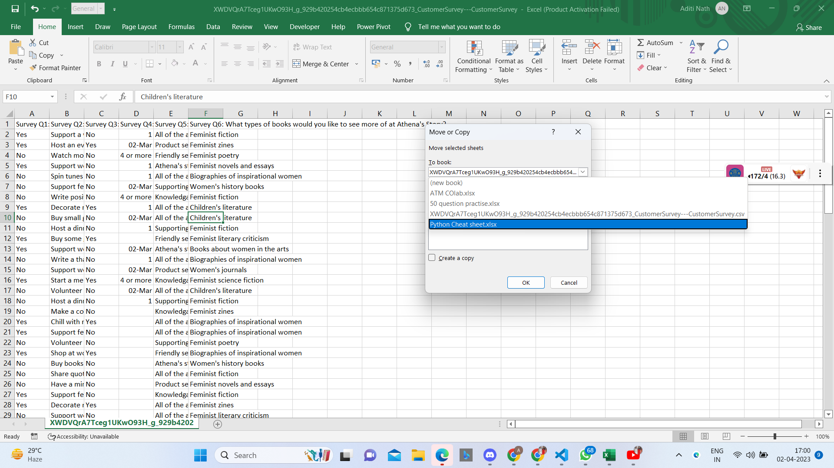

**Which key is used as a shortcut for opening a new window document?**

Ctrl+N

**What are the things that we can notice after opening the Excel interface?**

Worksheet

Title Bar

Quick ACess Toolbar

Row And Column Ribbon

Alignment and etc

**When to use a relative cell reference in excel?**

Whenever calculations need to be repeated.